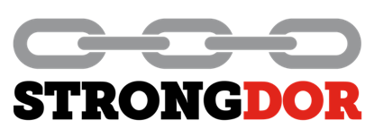 | SHEQ Policy  Approved by P. Irvine 10.07.26 | Ref | PO-001
 | SHEQ Policy  Approved by P. Irvine 10.07.26 | Issue Date | 10.07.26
 | SHEQ Policy  Approved by P. Irvine 10.07.26 | Revision | 04
 | SHEQ Policy  Approved by P. Irvine 10.07.26 | Page | Page 1 of 1

Safety Health Environment and Quality (SHEQ Policy)
Strongdor Ltd are specialists in the manufacture and supply of quality steel doors for commercial clients throughout the UK and Europe.
The senior management of Strongdor Ltd believe that to ensure customer satisfaction and product conformity the integrated management system (IMS) must be aligned with the business context and strategic direction of the company. By implementing an IMS in accordance with the ISO 9001: 2015 + ISO 14001:2015 + ISO 45001:2018 standards a structured and systematic management system has been created, ensuring that this alignment is maintained.
We are committed to Customer Satisfaction and conforming to other applicable requirements. We ensure that through the effective implementation of this IMS that customer's requirements are always met. Our experienced staff are committed to work according to the following 3 rules:

Understand customer requirements.
- Customise our product accordingly.

Respect the British and European Standards.

Overall responsibility for this policy rests with the Executive Management Team (EMT). Directors shall demonstrate leadership, commitment and encourage employee participation in support of this policy.
In pursuance of this policy the EMT of Strongdor Ltd commits to:
- Provide a safe and healthy workplace, reducing risks as far as possible, protecting the environment, conserving energy and natural resources and preventing pollution, through proper management and review.
- Monitor and measure our performance and comply with, Health, Safety and Environmental laws and Global Standards.
- Ensure quality and environmental and OH&S objectives are established and compatible with the context and strategic direction of the organisation alongside integration of the IMS to the business.
- Periodically review our SHEQ targets and objectives, practices and procedures, to address changing circumstances, continually improve our IMS and enhance our performance.
- Promote a culture where it is the responsibility of the management, employees and persons working for or on behalf of Strongdor to work together to ensure the quality of the product, the protection of the environment and the health and safety of all those involved.

- Consultation and participation of workers.
- Making this policy available to all persons working for or on behalf of Strongdor, vendors, customers and the public.

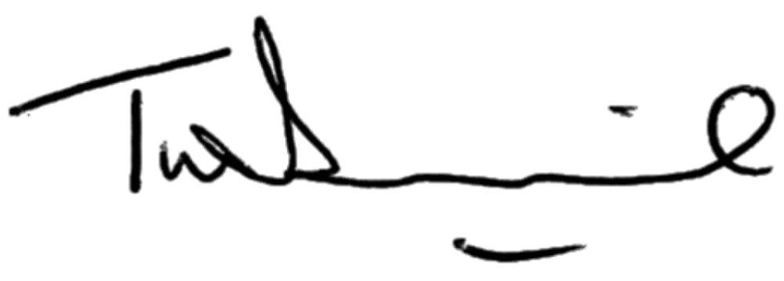

Tim Devenish – Global CEO
10th July 2026

