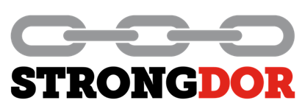 | Sustainability Policy  Approved by P. Irvine 02.01.26 | Ref | PO-003
 | Sustainability Policy  Approved by P. Irvine 02.01.26 | Issue Date | 02.01.26
 | Sustainability Policy  Approved by P. Irvine 02.01.26 | Revision | 02
 | Sustainability Policy  Approved by P. Irvine 02.01.26 | Page | Page 1 of 1

Sustainability Policy
Strongdor Ltd are specialists in the manufacture and supply of quality steel doors for commercial clients throughout the UK.
Strongdor Ltd are committed to promoting sustainability and continually working to reduce the environmental impacts of all aspects of our business.

Strongdor aim to:
- Comply with all applicable legislation, regulations and codes of practice, exceeding these requirements when practical.
- Integrate sustainability into all our business decisions.
- Minimise waste.
- Use green energy sources where possible.
- To ensure all staff are aware of the sustainability policy and are committed to its goals.
- To make interested parties aware of the sustainability policy and encourage them to adopt sustainable practices.
- To review the policy annually at the management review meeting and continually improve the sustainability of the business.

Examples:
- Use green energy tariffs.
- Monitor and measure our use of utilities.
- Use LED bulbs and sensor-controlled lighting.
- Variable drive compressors.
- Reduce waste, powder paint reclaim, minimise packaging.
- Recycling – cardboard compactor, steel, batteries, paper, ink cartridges.
- Purchase energy efficient equipment.

- Fleet cars are electric or hybrid where possible.
- Reduce carbon footprint – cycle to work scheme.
- Avoid unnecessary travel by using other forms of communication.
- When travel is necessary plan the route and take the most fuel-efficient option.

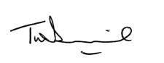

Tim Devenish – Global CEO
02nd Jan 2026

